Managed Group 6-Layered Architecture Diagram
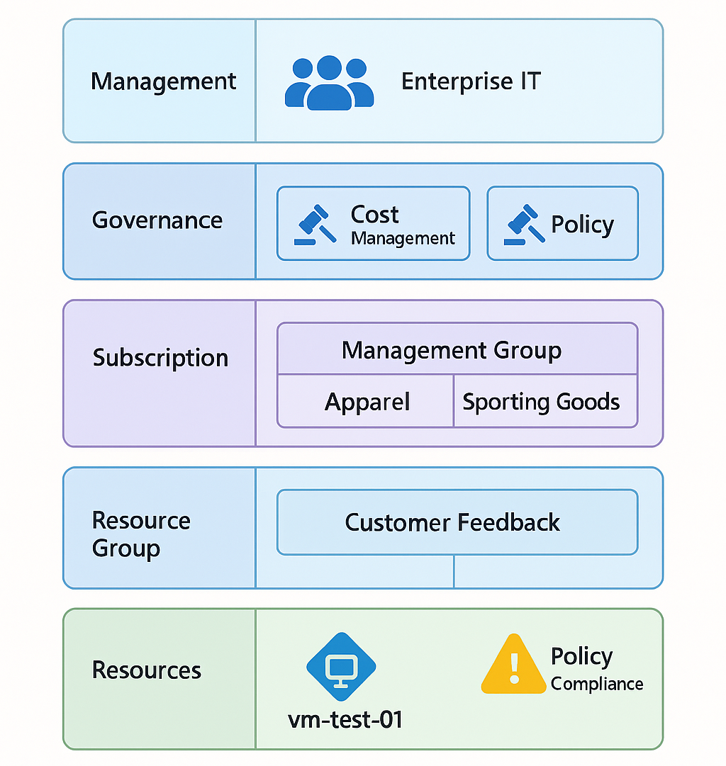

Managed Group 6-Layered Architecture details step-by-step:

- Enterprise Root Management Group
  - Centralized control by Enterprise IT.
  - Provides company-wide cost reporting and governance.
- Business Unit Management Groups
  - Apparel
  - Sporting Goods
  - Each unit has its own management group for accountability.
- Department Subscriptions
  - Product Development, Marketing, Sales under each business unit.
  - Enables granular cost tracking and reporting.
- Project Subscription / Tagged Resources
  - Dedicated subscription or tagged resource groups for the Customer Feedback Project.
  - Ensures CFO visibility into project-specific costs.
- Azure Policy & Blueprints
  - Enforce VM sizing (low-cost SKUs for testing).
  - Enforce naming conventions (CFB-Test-VM01).
  - Automatically flag non-compliance.
- Enterprise IT Cost Reporting & Monitoring
  - Roll-up reporting across all subscriptions.
  - Dashboards for spend analysis, compliance, and performance monitoring.

- Cost Optimization: Clear accountability per unit + project tagging (lableing).
- Operational Excellence: Policies and blueprints enforce standards.
- Security & Reliability: RBAC and monitoring at management group level.
- Performance Efficiency: Right-sized resources for testing and scaling.
This layered approach ensures clarity, compliance, and efficiency while aligning with the Azure Well-Architected Framework pillars.

